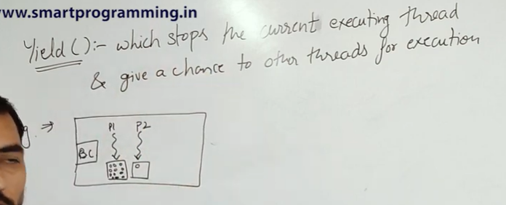

BASED ON THREAD SHEDULAR , IT IS DECIDED WHICH THREAD TO RUN FIRST , EVEN IF A THREAD RUNS FIRST IT IS NOT MANDATORY THAT IT WILL BE EXECUTED FIRST !!

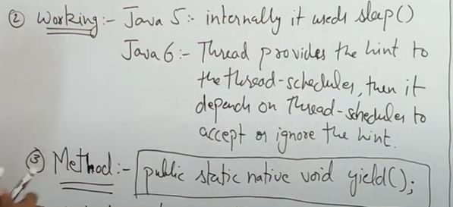

1. From java 6 , yield method provides hint to thread shedular that it can stop now and other threads can run but it depends on thread sheduldar whether It will drop it currently and continue other threads or not . Even we cant determine which one it will pick same priority or higher priority thread.
2. Static method hence can be accessed directly using Thread class.

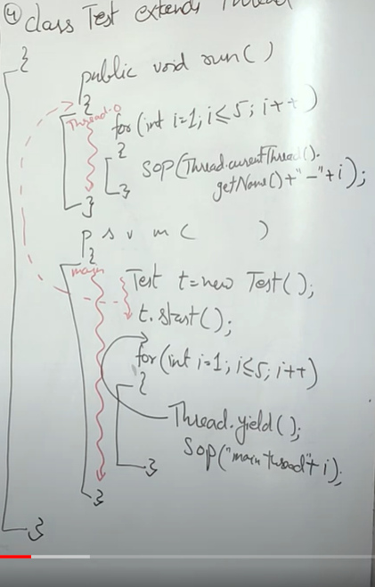

If we want the main method , ( 1 – 5 ) loop to yield I.e wait or execute later then above code will work .However all these things are platform dependent .So desired output may not be achieved.

In the above code we can put thread.yield() before the loop outside ( shown using arrow ) also .

A>>

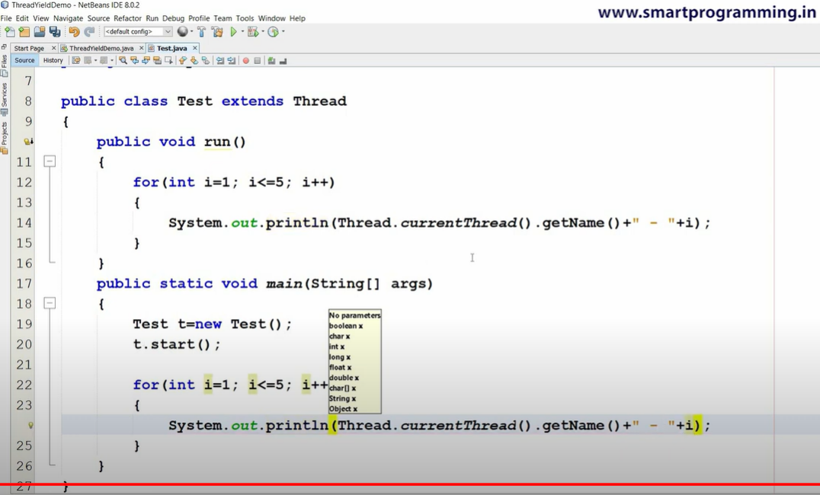

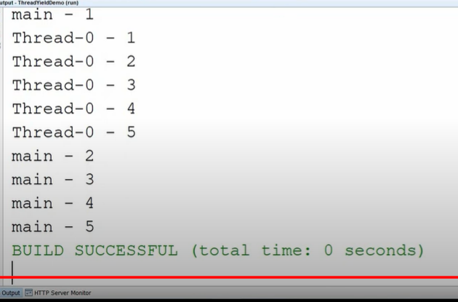

Simple code both threads running concurrently . However running it results in various output ( platform dependent and windows do not support )

For example the same code may result the below 2 outputs.

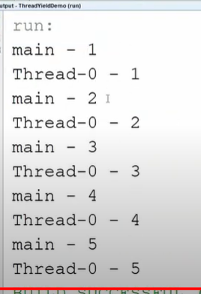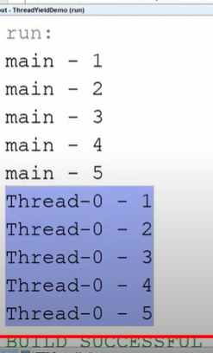

Right one looks like we have used yield() , but we haven’t use.

B>>YIELD MAIN METHOD ( Don’t think of output , only learn to code )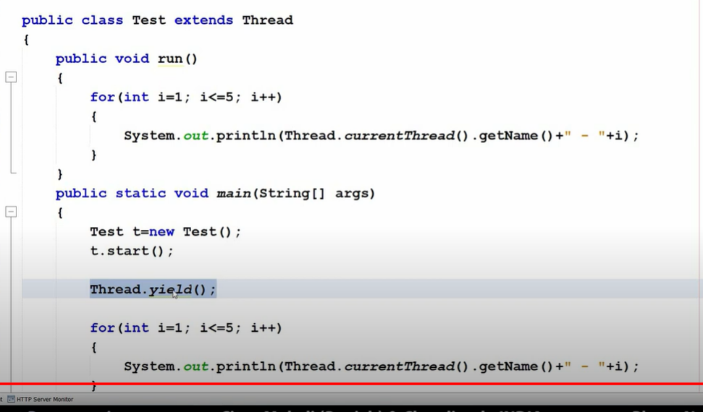

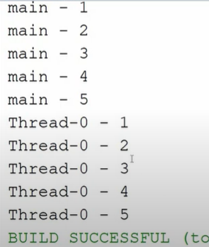

OUTPUT ACHIEVED IS TOTALLY OPPOSITE THAN WE EXPECTED SINCE WE USED YIELD MAIN METHOD STILL MAIN METHOD EXECUTED FIRST .

C>> YIELD RUN METHOD

